Jingbin Yin’s reflection

This is a pretty interesting assignment about teamwork.In these week, I learn about how to use the github and get the gerneral knowledge about the IT job. Also, this is a funny process to work with my group. We have a disscuss about our ideal job and our project. I am happy to share my opinion to my group member. It make me excited that there are some one have a similar dream with me.

Summary work done by myself:

1. Participate into the group meeting.

2. I fill up the team profile of mine.

3. Draft the industry data part and analyze the data.

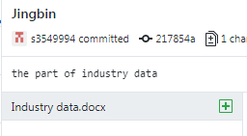



Here is the github log which is done by me.

Project meeting time:

16/04/2018: We finished our team profile and set up a website. We got our distribution.

23/04/2018: We have discussion on this assignment about what needs to be done, and we discussed about IT area and jobs.